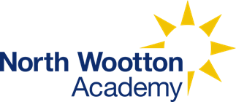 | North Wootton Academy  Priory Lane  North Wootton  Kings Lynn  Norfolk  PE30 3PT
Name of policy: | Phonological Development  (Phonics & Spelling)
Lead member of staff with responsibility for this policy: | Emma Harley-Bond
Date of governors meeting when policy agreed: | NA
Type of governors meeting: | NA
Date of implementation: | Wednesday 3rd September 2025
Details of dissemination: | This policy is available on our school website and is available on request from the school office.
Frequency for review: | Annually

Phonics Pupil Statement
“In our Phonics lessons, we learn to segment and blend words to read and spell.”
Today, we are Decoders:
Spelling Pupil Statement
“In Spelling, we understand the meaning of new words, where they originate from and spelling rules.”
Today, we are Spellers: we use the morphology and etymology of words to support our knowledge and retention of spelling.
Intent of Phonics and Spelling
Here at North Wootton Academy, we aim to create a love for Reading, Writing and Spelling. We want every child to leave the school with the skills of an outstanding reader, writer and speller.
We believe that being able to read and spell are two of the most important skills children will learn during their education.

The journey of phonological development begins in the EYFS through Key Stage 1 and into Key Stage 2 with high quality Phonics. As children leave the EYFS and enter Key Stage 1, their phonological development is enhanced using discrete Spelling lessons twice a week in addition to Phonics.

We believe that consistency within Phonics and Spelling lessons will give children the best possible start to their reading and writing journey.

For children to be able to read and understand the texts they have read, or had read to them, they must learn to recognise and decode words on the page. Good quality Phonics teaching allows the child to be secure in the skills of word recognition and decoding which allows the child to read fluently. We believe that if children have secure decoding skills, this will support their encoding skills for writing.

Implementation of Phonics
The table below demonstrates teaching and learning time dedicated to Phonics and Spelling.
Year Group | Phonics | Spelling
EYFS | Daily  5 times per week
Years 1 and 2 | 3 times a week | Twice a week
Years 3 and 4 | Catch Up Teaching  (if required) | Once a week
Years 5 and 6 | Catch Up Teaching  (if required) | Once a week

Phonics is taught as a whole class approach to ensure that quality first teaching is accessible to all children. Phonics is also continued in Key Stage 2, where necessary, to support those children who do not yet have the phonic knowledge and skills they need. This is led by a specified member of support staff to ensure that there is a strong continuity into Key Stage 2. Children in the EYFS are introduced to Phonics from day 1 with a brief recap on Phase 1 Phonics. From the second full week of school, children begin formal teaching of Phonics.
Teaching and Learning
The school has chosen not to follow one accredited Phonics scheme but instead research several and integrate the most effective elements of each. This has enabled the school to ensure that it has flexibility in its provision to meet the specific needs of our pupils. The main priority therefore is ensuring that all staff are consistent in teaching our approach rather than following a set scheme.
The approach itself is in the main a combination of Read, Write Inc (RWI), Letters and Sounds and Jolly Phonics. We use the bouncy and stretchy concept to identify phonemes from Read, Write Inc and the phoneme songs from Jolly Phonics as it is believed this multi-sensory approach best supports our learners in knowing and remembering more. In addition, the lesson sequence each week is heavily influenced by RWI in which pupils spell, read and then write using the focus phonemes. Beyond this, the progression through the various stages of sounds links closely to the Letters and Sounds document with some small exceptions such as the split vowel digraphs.
Phase 2
Within Phase 2, children are taught at least 3 graphemes each week and 2 sight words. As soon as each set of graphemes is introduced, children will be encouraged to use their knowledge of phonemes to segment and blend words. In total, 23 GPCs are taught and 12 sight words. Digraphs are lightly introduced at this stage.
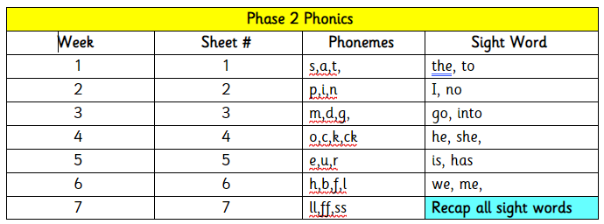
Phase 3
By the time they reach Phase 3, children should already be able to segment and blend words containing the 23 graphemes taught in Phase 2.
Within Phase 3, children are introduced to 35 new GPCS and 29 sight words. Digraphs, trigraphs and split vowel digraphs are heavily taught in Phase 3.
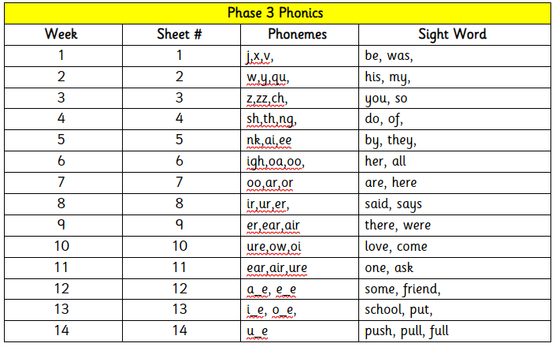
Historically, children would then naturally progress onto Phase 4, however, at North Wootton Academy, we have merged phase 4 knowledge and skills into Phase 3. As outlined in this policy, we have kept the original phase names identified from the old Letters and Sounds document.
Phase 5a
Children entering Phase 5 should already be able to read and spell words with adjacent consonants, such as trap, string and flask. They should also be able to read and spell some polysyllabic words.
Within Phase 5a, children consolidate the teaching of split vowel digraphs before moving onto 18 new GPCS. In total, 39 new sights words are learnt.
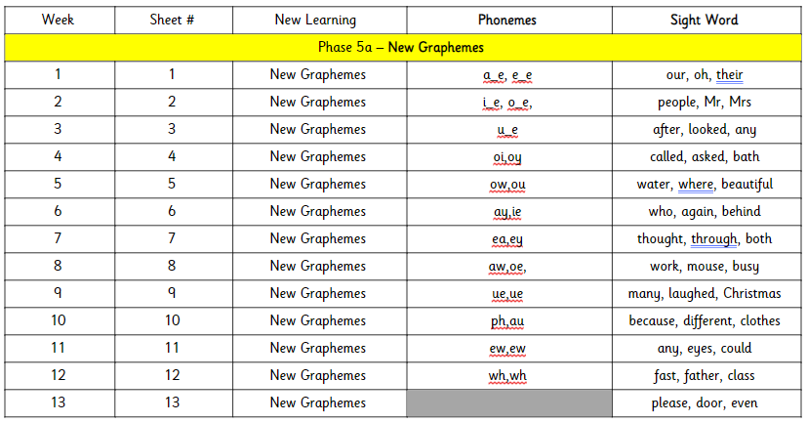

Phase 5b
Phase 5b is where children will learn that graphemes have alternative pronunciations, for example, ‘i’ as in t-i-n and ‘i’ as in m-i-l-d.
There are 13 sets of alternative pronunciation graphemes and 36 sight words.
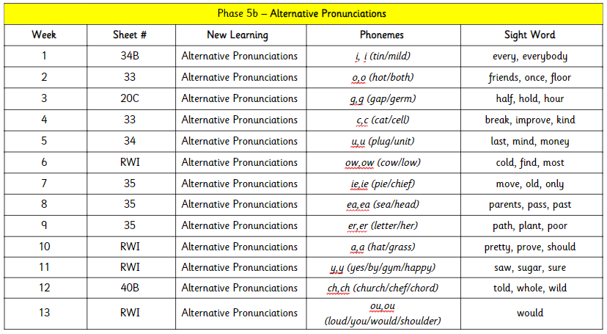
Phase 5c
Alternative spellings of phonemes are introduced in Phase 5c. Children will learn that the phoneme ‘ai’ can be represented 6 different ways (a_e, ay, ai, eigh, a, ey). No new sights words are introduced.
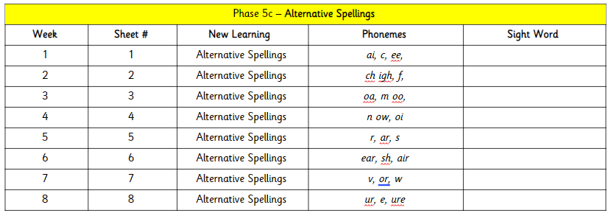
Phase 5d
Phase 5d is the transitional stage from Phonics to Spelling. Children are taught 7 suffixes and 1 pre-fix as an introduction to spelling rules.
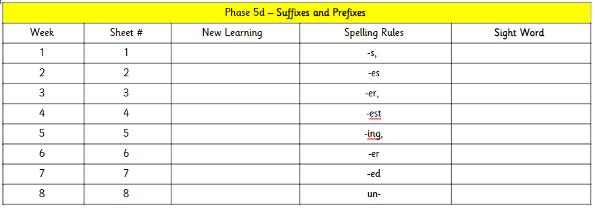

Phonics Sound Buttons and Sound Boxes
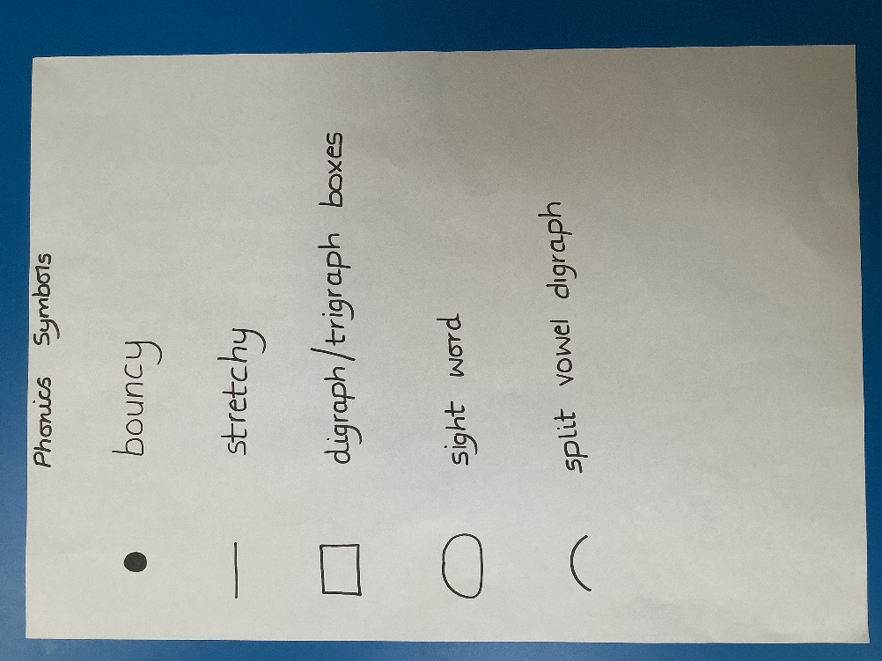
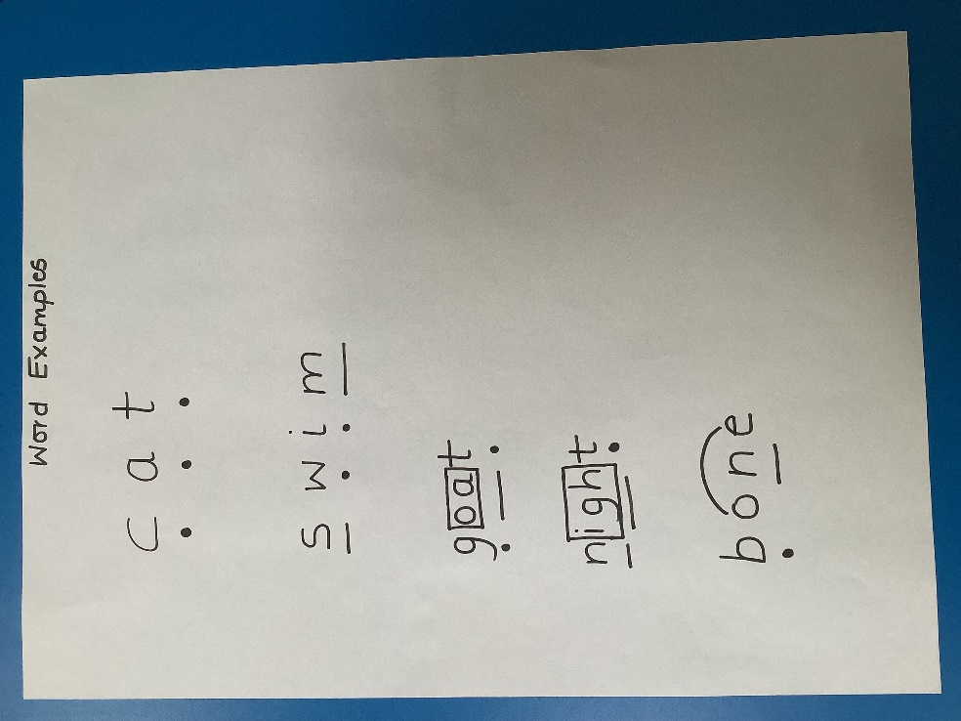

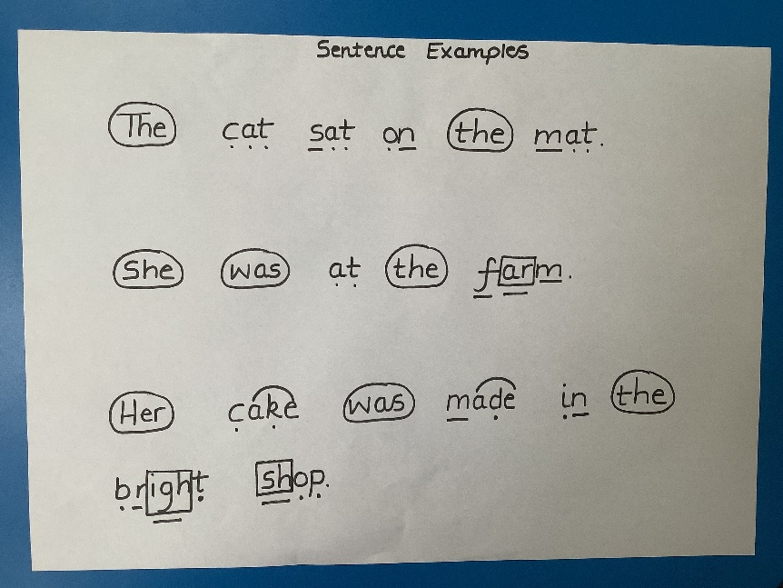
Home Reading
In Reception, Phonics is clearly linked with early reading with children taking home two different reading books: one is based on the GPCs taught in the week and the other one being a colour banded book that provides breadth and exposure to a wider range of words.
As they progress through Key Stage 1, the children will progress through the colour banded books.
Implementation of Spelling
As a school, we have chosen to teach Spelling through the Spelling Shed programme which teaches spelling in a fun and engaging way. Children will begin their learning of Spelling in Key Stage 1, Year 1 and it will continue into Year 6.
Spelling Shed is an interactive and engaging programme which uses a variety of resources and activities to support the children with their spelling. It helps children to learn spellings with common patterns and uses rules to help them recall spellings as well as teaching exceptions to these rules. Each week a new pattern is introduced which is outline below.
Spelling lists reflect the English National Curriculum Appendix 1. This appendix provides examples of words embodying each pattern which is taught. Many of the words listed as ‘example words’ for years 1 and 2, including almost all those listed as ‘exception words’, are used frequently in pupils’ writing, and therefore it is worth pupils learning the correct spelling. The word-lists for years 3 and 4 and years 5 and 6 are statutory. The lists are a mixture of words pupils frequently use in their writing and those which they often misspell. All year groups will cover the statutory requirements from the English National Curriculum Appendix 1.
Each lesson follows the same structure:
- Revise and Introduction
Children revisit phonemes and spelling patterns from previous weeks. Children are then introduced to this week’s words.
- Main Teaching Input
Here children explore the words of the week. They examine aspects such as the number of syllables, tricky phonemes and the morphology of the words.
- Independent and Consolidation
The independent section is designed to be carried out by students with minimal instruction. They are carried out immediately after the teaching input in class during an extended spelling session.
Range of Activities
Sorting Words
Syllable Maps
Segmenting Words
Sound Buttons
Cloze Sentences

Morphology and Etymology is also used to teach spelling.

Morphology
Morphology is the study of words and their parts. In terms of their architecture, words can be placed into two distinct categories. Words such as ‘car’, ‘skill’ and ‘pen’ seem to exist in whole forms. The word as a whole holds the full meaning. The second category of words, such as ‘walking’, ‘inconceivable’ and ‘disagreement’, can be split into a number of sections with each section holding a portion of the whole meaning.
A morpheme is the smallest unit of meaning in a word. For example, the word ‘dogs’ is made up of two morphemes. These are ‘dog’ meaning a canine animal and ‘-s’ which pluralises the noun to show that there is more than one.
Etymology
Looking at the etymology of words and word parts can help children to spot patterns which are helpful when spelling. When looking at morphology it is worth noting that we can explore the word origins of both roots and affixes.
Please see appendix 1 for the spelling MTP.
Impact of Phonics
At the end of each phase in Phonics, children are assessed on their knowledge of content. They are assessed on a number of key areas:
- Can they children identify a grapheme (multiple choice) for a given phoneme?
- Can they represent a phoneme as a grapheme?
- Can they read words containing newly learnt GPCs?
- Can they spell words containing newly learnt GPCs?
- Can they read newly learnt sight words?
- Can they spell newly learnt sight words?
In addition to end of phase assessments, children in the EYFS are tracked weekly to ensure gaps within knowledge do not develop and that catch up teaching can be administered immediately.
Children in Year 1 take part in the statutory assessment (Phonics Screening Check) in June. The purpose of the phonics screening check is to confirm that all children have learned phonic decoding to an age-appropriate standard.
Children who have not reached this level by the end of Year 1 should receive extra support to ensure they can improve their decoding skills, and will then have the opportunity to retake the phonics screening check in Year 2.
(Assessment framework for the development of the Year 1 phonics screening check, 2017)

All assessments are monitored termly through a data validation process in which data, books and teaching are reviewed by the subject leader and discussed with each teacher to ensure an accuracy in assessment. All SEND, EAL and pupil premium champions track these cohorts specifically on a half-termly basis and conduct pupil progress reviews twice yearly. With regard to SEND, this may involve the reviewing of their progress on North Wootton SEND Pathway as required for pupils 2 years below the expected level.

Within the EYFS, key milestones have been identified across the year and these are used to assess the children’s progress towards meeting the ELG for writing; this enables the more timely identification of any gaps that need addressing.

End of School Year Age Related Expectations:

All children should be taught the four Phonics skills:

- Phonemes (sounds) are represented as graphemes (letters).
- To blend phonemes in order to read the word.
- To segment spoken words into phonemes for spelling.
- Blending and segmenting are reversible processes.

By the end of EYFS children should:
- Be able to read and understand simple sentences.
- Be able to use Phonics knowledge to decode common words and read them aloud accurately.
- Be able to confidently read, by sight, Phase 2 and 3 tricky words/common exception words.
- Be able to use Phonics knowledge to write words in a way which match their spoken sounds.
- Be able to write some irregular common words.

By the end of Year 1 children should:
- Be able to apply Phonics knowledge and skill as the prime approach to reading unfamiliar words that are not completely decodable.
- Be able to read many frequently-encountered words automatically.
- Be able to read phonically decodable three-syllable words.
- Be able to read a range of age-appropriate texts fluently.
- Be able to demonstrate understanding of age-appropriate texts.
- Be able to read decodable words that end –s, –es, -ing, -ed, -er, -est.
- Be able to say the correct phoneme to grapheme for all the 40+ phonemes up to Phase 5.

By the end of Year 2 children should:
- Be able to read accurately most words of two or more syllables.
- Be able to read most words containing common suffixes.
- Be able to read and spell most common exception words for year 2.
- Be able to read words accurately and fluently without overt sounding and blending.
- Be able to sound out most unfamiliar words accurately, without hesitation.
- Be able to segment spoken words into phonemes and represent these by graphemes.
Catch up Teaching
Children who still need extra support to develop their phonic knowledge across the EYFS, Key Stage 1 and 2 are identified and targeted for intervention. There are a range of intervention strategies which the school uses and the most appropriate one is selected once a child’s needs have been assessed.
Impact of Spelling
Children are given weekly spelling tests to assess whether they have learnt and remembered the focus works within the week’s lessons. These are tracked and monitored by Phase Leaders and the Spelling Lead. Any child who isn’t achieving 75% or more in their weekly spelling tests will access catch up teaching.
In addition to these weekly spelling tests, children are also assessed on their year group word lists termly.
Review
The governors review this policy annually. The governors may, however, review the policy earlier than this, if the government introduces new regulations, or if the governing body receives recommendations on how the policy might be improved.
Updated: 31st August 2025
Review: August 2026
By: Emma Harley-Bond (EYFS Leader)

