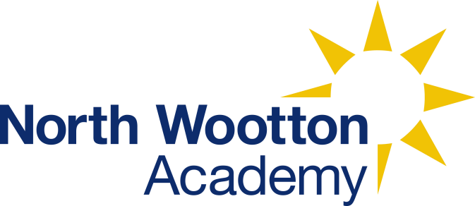 | North Wootton Academy  Priory Lane  North Wootton  Kings Lynn  Norfolk  PE30 3PT
Name of policy: | PHSE Policy
Lead member of staff with responsibility for this policy: | Michele Buschman
Date of implementation: | 17th April 2023
Details of dissemination: | The policy is available for all staff, visitors, pupils and parents on the school website.
Linked Policies: | Most curriculum policies  Anti-Bullying Policy  Safeguarding Policy  Relationships and Sex Education Policy  Curriculum Policy  Online Safety Policy  Positive Behaviour Policy
Frequency for review: | Annually
In PSHE, we aim to be good citizens:
We make links between knowledge of the modern world and ourselves so we can positively, safely and spiritually impact our lives and the lives of others.
Intent
The intent of our PSHE curriculum is to deliver a curriculum which is accessible to all with knowledge and skills to help pupils to stay healthy, safe and prepare them for life and work in modern Britain. When taught well, PSHE education helps pupils to achieve their academic potential, and leave school equipped with skills they will need throughout later life.
Our aim is to broaden cultural capital for every pupil providing them with a knowledge of their world, locally, nationally and globally and give them confidence to tackle many of the moral, social, spiritual and cultural issues that are part of growing up within this. We aim to provide our children with opportunities for them to learn about rights and responsibilities and appreciate what it means to be a member of a diverse society. British Values are a key part of this. Our pupils are encouraged to develop their sense of self-worth by playing a positive role in contributing to school life and the wider community.
We challenge all of our pupils to look for opportunities to show the school values of TEAMWORK and seek leadership opportunities within the school gates and their local community both now and in the future as ‘Leaders for Lynn’.
Implementation
It is hoped that our overall curriculum is designed to directly support the pastoral education of our pupils as well as the academic outcomes that the school aims for. The school primarily uses resources from ‘Young Citizens’ (linked to the Citizenship Foundation) to make links between our academic aims and the modern world in which they find themselves, empowering them to operate positive, independently and safely within it. As much as possible, the curriculum has been designed to ensure that this subject acts as a ‘golden thread’ running through all subjects that are taught:
- History aims to link knowledge of Britain’s past to the diverse and democratic country that we live in today through areas such as immigration, refugees and parliamentary debate. It represents the journey to our present British Values.
- Geography aims to ensure our pupils have a wide knowledge of the world and the diverse cultures that exist beyond our school gates linking to topics such as Fairtrade and World Aid.
- English includes texts that explore complicated issues such as slavery and the holocaust.
- Science links the statutory learning outcomes with environmental issues and areas of physical challenge such as disability.
- Computing lessons prioritize teaching safe responsible online citizens before being shown the tools needed, through Rising Star’s Online Safety.
- Within the PE curriculum, there is a focus upon road safety with initial cycle training beginning from Reception.
- Relationships and Sex Education dove-tails directly with areas of the PHSE curriculum in teaching positive and safe relationships, even though it can be seen as a separate subject.
In addition to ‘Young Citizens’, the school has selected lessons from a range of other education groups to ensure that are coverage is broad and extensive:
- Parliamentary Education Services linked to the importance of Fundamental British Values and verbal debate
- Educate Against Hate and Schools Out supporting an understanding of tolerance and understanding
- The Royal National Lifeboat Institution linked to the teaching of water safety
- Brake promoting road safety
- Sun Safe Schools promoting the importance of adequate sun protection
With the increased focus being on our pupils’ mental health, as well as physical, we have appointed a Senior Mental Health Lead – Michele Buschman.
Frequency
It is hoped that our pastoral curriculum is interweaved throughout our curriculum; however, a lesson a week is timetabled to ensure that quality time is dedicated to these areas.
School Values
Beyond our documented curriculum, it is hoped that the school’s values of TEAMWORK provide a culture that contributes equally towards the pastoral development of our children.
Therefore, our teaching approach and the wider opportunities that we provide place great emphasis upon positive opportunities for collaboration, discussion and leadership:
- Group work should be a key element of all classroom learning
- Opportunity for team performance in competitive sports, choir and drama productions
- Leadership in their community through House Captaincy, Student Council, Playground Leaders, Digital Leaders and Sports Leaders
- Volunteering opportunities through Gardening and Eco Committees.
Impact
Whilst learning is recorded, the width of our provision means that a range of measures are used:
- Participation in extra-curricular activity both in school and beyond is tracked and celebrated through Children’s University.
- Pupil Voice Surveys are used to assess knowledge of how to stay safe and emotionally confident within the school.
- Levels of volunteering both within the school through litter picking, librarians and playground leaders, and within the community through community litter picks, choir concerts within local care homes and supporting the local foodbank.
As many lessons are discussion based, we also assess their ideas and contributions to these class discussions using our Speaking and Listening Policy. This can be both teacher and peer assessed.
At the end of each half term, the children complete six assessment quiz questions to assess the level of knowledge they are developing.

