North Wootton Academy
Written Calculation Policy

Aims:

Our calculation policy aims to ensure that all pupils:
- understand important concepts and make connections within mathematics
- show high levels of fluency in performing written and mental calculations
- are taught consistent calculation strategies
- are ready for the next stage of learning
- have a smooth transition between phases
- are able to add, subtract, multiply and divide efficiently
- are competent in fluency, reasoning and problem solving.

Our approach:
We believe that it is fundamental for children to be able to move from conceptual learning to abstract learning in order to be able to successfully understand, use and apply their mathematical skills. The calculation strategies which will be used will reflect this ideology – moving from concrete to pictorial and then abstract recording (CPA), leading to more formal written methods. Mental methods and strategies will work in partnership with these methods.

Representations:
We believe that representation is key is developing conceptual understanding in mathematics. Pupils should all have an opportunity to manipulate and experience a variety of models, images, and resources to enable them to choose the most suitable representation for each calculation. Every class is provided with Maths Toolkits filled with a range of resources to allow the children to support them in the CPA approach of learning to calculate and discover the underlying structure of mathematical concepts.

Addition

Definition
Addition is the process of calculating the total of two or more numbers or amounts. It is the inverse of subtraction.

Mental Calculations
- Counting forwards and backwards.
- Understanding that addition is commutative
- Partitioning
- Recalling number bonds
- Using subtraction as the inverse of addition

Key facts and expectations
The fundamental principles of addition and key addition facts are built upon as children progress throughout the school.

Reception:
Reception is the first exposure that children have to the composition of numbers. Within the EYFS mathematics curriculum, learning about how numbers up to 10 are constructed is a key element. This is shown through use of tens frames, numicon and part-whole models. During ‘number of the day’ one of the focuses is composition and embedding that numbers are composed by adding together other numbers. Children within EYFS will learn all number facts for all numbers within 5 by the end of their Reception year.

Year 1 and 2:
As children progress into Year 1 and 2, the learning from EYFS is built upon through consolidation of key addition facts. Patterns are explored and the underlying structure of addition is exposed. Alongside this, strategies for calculating addition facts are introduced and along with the commutative law, children will learn addition facts up to 10 + 10 by the end of KS1.

The image below shows the key facts including strategies that are used to learn these facts and when the facts will be focused on. Daily retrieval of this information allows children to embed this knowledge securely before progressing into Key Stage 2.

Key Stage 1 addition facts

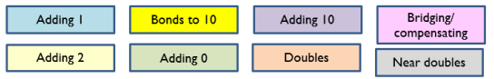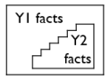

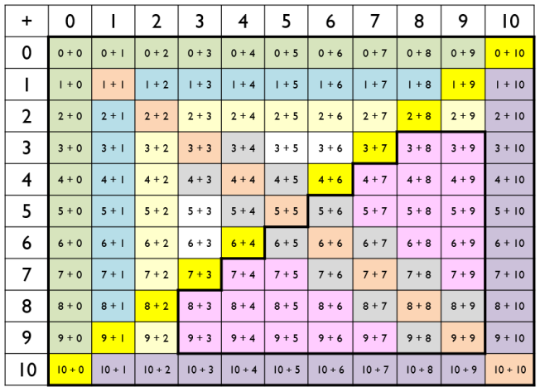

Year 3 and 4:
In Year 3 and 4, children will learn how to apply their previous learning through a variety of different ways. Secure knowledge of addition facts is applied through the formal written method of column addition and children begin to apply their knowledge to multiples of 10 such as using 9 + 3 = 12 to help them with 90 + 30 = 120. Additionally, children will apply their addition facts to help them to mentally add 2 and 3 digit numbers using known number bonds. e.g. 57 + 8 is knowing that 7+8 = 15 so 57 + 8 = 50 + 15 which is 65.

Year 5 and 6:
In Year 5 and 6, children will learn how to apply their previous learning to add decimal numbers mentally e.g. using 7 + 6 = 13 to support addition of 0.7 + 0.6 = 1.3 as well as consolidating prior learning.

Representations in Reception
Using a range of practical resources and real life contexts, pupils develop their understanding of the concept of addition through counting activities. They then use pictures/diagrams to represent the calculation. E.g. There are 2 birds. Another bird flies in. How many are there altogether?
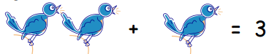

The tens frame and numicon should be used alongside more informal representations to support children in representing and understanding number.
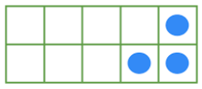
These frames can then be used to support children in adding together numbers using double sided counters and reinforcing with numicon.
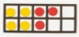

Written Calculations

Strategies used in Year 1

To support with addition of two 1 digit numbers and to promote partitioning in different ways, tens frames are a good visual and concrete representation. This leads on from representations in Reception.
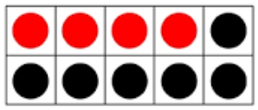
Using tens frames to support bridging 10 when adding two numbers together also supports children in developing their understanding of the composition of numbers and different ways to partition.
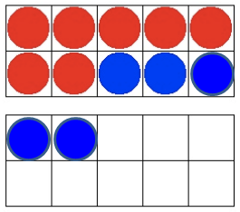
Example: 7 + 5

This representation will support the children with application of their number bonds as it shows how many more to make the next multiple of 10 as well as showing that 12 can be made up by adding 7 + 3 + 2.

Number tracks/lines
- Using a number line to add

e.g. 4 + 2
- Begin with a number track:

This will then progress onto partial number lines using more efficient strategies.

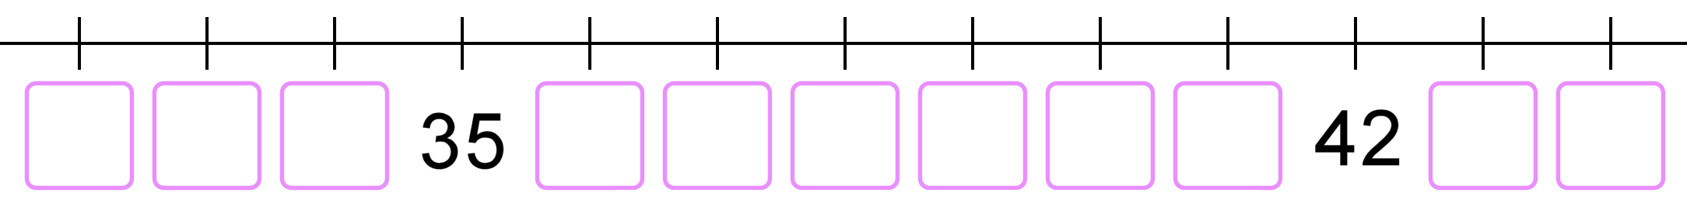

Strategies used in Year 2

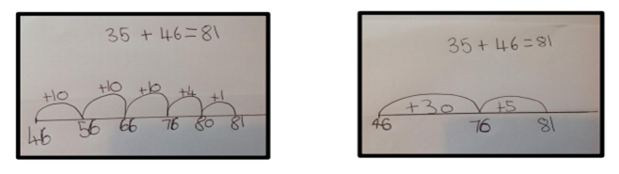
Children in Year 2 should continue to work on addition using the number line and developing the efficiency of strategies learnt in Year 1, moving onto blank number lines to develop number sense. Use of tens frame will continue to help children to develop their understanding and application of number bonds (see images referenced in Year 1 and Reception).

Additionally, children should be shown how to apply their understanding of number composition and how to partition numbers using place value.

This should be supported using concrete and pictorial representations like the ones below.
Dienes could be used to initially secure place value, leading into use of coins/PV counters when secure and then onto pictorial representations.

Children should be taught to always add up the ones first as this will support when they move on to more efficient methods in the future.

Concrete (dienes, moving on to coins or PV counters) Pictorial
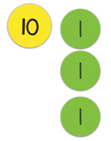
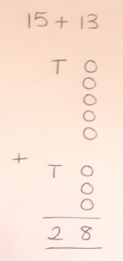
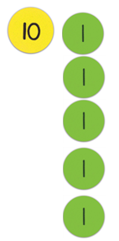
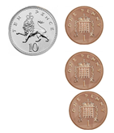

This can then progress onto using exchange where needed using the same representations.

Concrete Pictorial
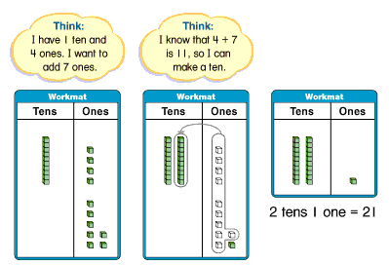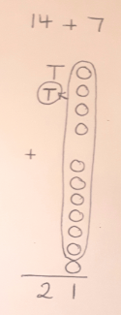

Strategies used in Year 3

Partitioning and recombining:
Once again, the process should be demonstrated using concrete resources, then pictorially before moving onto the abstract. As with Year 2, the ones should always be added first so that this supports the formalised version of addition used later on. Once place value is securely established, H, T and O can be used to represent 100, 10 and 1.

Concrete Pictorial Abstract
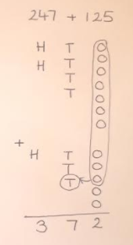
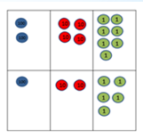
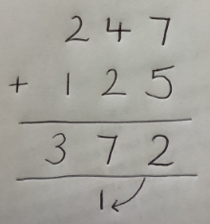
Strategies used in

The number line should continue to be used to support mental calculations where needed.

Strategies used in Year 4

Once children are secure and can demonstrate their understanding (through explanation as to why this works and show calculations in a variety of representations), compact column addition can be introduced.

At this stage, it is important to again revisit the concrete, pictorial and abstract when children are learning how to recombine as this will make explicit the link between place value and addition.

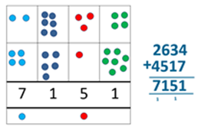
Concrete Pictorial Abstract

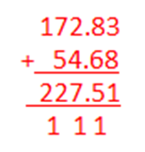
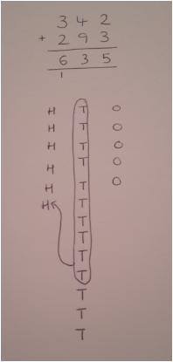

The number line should continue to be used to support mental calculations where needed.

Strategies used in Year 5 and 6

Year 5 and 6 are used as an opportunity to consolidate and become efficient in the compact column addition method.
This method should then be applied to a variety of different mathematical strands including decimals, money and measures as well as working with increasingly larger numbers as stated in the curriculum (up to 10 million by Year 6).

Additionally to this, students in Year 5 and 6 should work on problems that challenge the children to explain how the method works to develop secure place value knowledge. Examples of this include problems with missing digits.

The number line should continue to be used to support mental calculations where needed.

Subtraction

Definition
Subtraction is the process or skill of taking one number or amount away from another or finding the difference between two numbers.

Mental Calculations
- Counting forwards and backwards in ones, twos, fives, tens etc.
- Reordering.
- Partitioning: counting on or back.
- Partitioning: bridging through multiples of 10.
- Partitioning: compensating.
- Partitioning: using near doubles.
- Partitioning: bridging through 60 to calculate a time interval.
- Using addition as the inverse of subtraction.

Key facts and expectations
The fundamental principles of subtraction and key subtraction facts are built upon as children progress throughout the school.

Reception
In Reception, children are exposed to the concept of subtraction in a variety of ways and using different representations. Children are introduced to the concept of inverse as opposite and can begin to develop their understanding of subtraction and how it affects the composition of a number.

Year 1 and 2
Throughout Key Stage 1, children will consolidate their understanding of the inverse and be able to apply this to addition and subtraction. Securing and embedding knowledge of the addition facts will allow the children to also learn subtraction facts through fact families and daily rehearsal.
Year 3 and 4
As children progress into Key Stage 2, as with addition, they will consolidate their understanding of the inverse and apply their subtraction knowledge across differing questions. For example, if they know that 19 - 6 = 13 then this fact can help them to work out what 190 - 60 is.

Year 5 and 6
As with addition, in Year 5 and 6, children will continue to apply their knowledge of addition and subtraction facts to the addition and subtraction of decimals and across a further range of questions.

Written calculations

Representations in Reception
Using a range of practical resources and real life contexts, pupils develop their understanding of the concept of subtraction through counting activities. They then use pictures/diagrams to represent the calculation.

E.g. There are 3 birds. 1 flies away. How many are left?
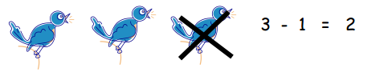
As well as using a range of different representations, the tens frame and numicon should be used alongside more informal representations to support children in representing and understanding number.
These frames can then be used to support children in subtracting numbers and reinforcing with numicon.

Strategies used in Year 1

Number track/lines to count back or take away:
Use a number line to take away, beginning with a number track e.g. 9-3
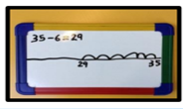
Progress to a partial number line to subtract a one digit number from a 2 digit number while counting backwards, e.g. 35-6.
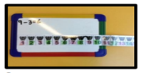

Number lines/tracks used to find the difference or count up

Use a number track to find the difference by counting up e.g. 7-4
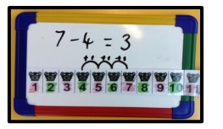
Progress to using number lines to find the difference e.g. 25-19 by counting in ones and then progress to using larger jumps. These methods should all be supported with use of concrete representations including bead strings, number squares and labeled number lines.

Strategies used in Year 2

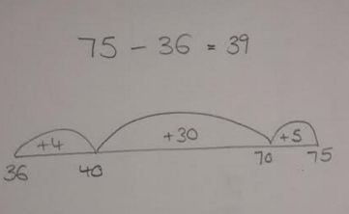
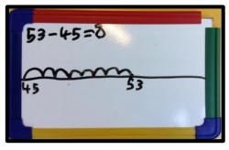
In Year 2, use of the number line should continue to be used and developed, progressing on to using blank number lines to find the difference and count up. This should be introduced by counting in ones and progressing to using larger jumps. Again, concrete apparatus should be used to support learning in this area (e.g. partially labelled number lines, bead strings, number squares).

Children in Year 2 should also be encouraged to apply their understanding of place value to support them in subtraction questions. As with addition, equipment should be used to support their concrete learning, before moving on to pictorial and abstract representations.
Once the largest number has been represented, start by removing the ones first as this will support with methods later on.

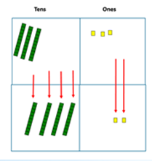
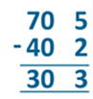
Concrete Pictorial Abstract

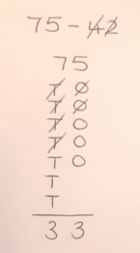

(Note: the dienes that are subtracted are completely removed)

This may lead onto use of exchange if you are unable to subtract the correct number of ones from the original amount. Physical exchange of a 10 to ones will occur with the concrete equipment.

Pictorial
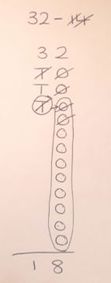

Strategies used in Year 3

Children will continue to consolidate their understanding of column subtraction involving decomposition. Once again, this should be represented using concrete equipment, then pictorially when place value is established and moving on to an abstract form. As with addition, once PV is established, the notation of H, T, O can be used to represent 100, 10 and 1. Once the larger number has been represented, always start by subtracting the ones to support development of the method.

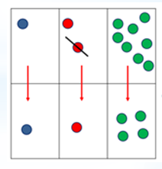
Concrete Pictorial Abstract
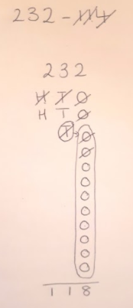
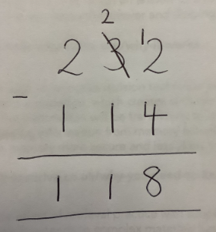

The number line should continue to be used to support mental calculations where needed.

Strategies used in Year 4

Once children are able to demonstrate a good level of understanding of place value, they can progress onto the decomposition method below e.g. 6232- 4814 with 4 digit and larger numbers (including decimals).

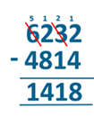
Concrete Pictorial Abstract
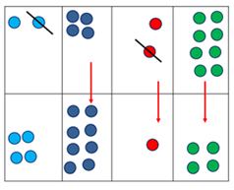
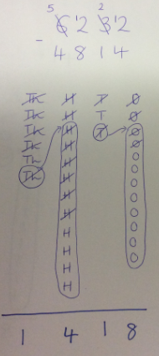

The number line should continue to be used to support mental calculations where needed.

Strategies used in Year 5

The abstract form of column subtraction including decomposition should be consolidated (going back to pictorial and concrete if necessary). This should then be applied to increasingly larger numbers in line with the curriculum (numbers up to 1 000 000) including decimals. This should occur across a range of mathematical areas including measures and money. Application of this should be seen through the use of missing number problems.

Strategies used in Year 6

Consolidation and application of the efficient method of column subtraction, using increasingly larger numbers and across a range of different mathematical areas.

The number line should continue to be used to support mental calculations where needed.

Multiplication

Definition
Multiplication is the product of two numbers or repeatedly adding the same set of number as many times as the other number. Therefore 3 multiplied by 4 is 4 lots of 3, or 3 added repeatedly 4 times. It is an inverse operation of division.

Mental calculations
- Counting forwards and backwards in equal steps e.g. in 2’s, 5’s, 10’s
- Repeated addition
- Rapid recall of multiplication facts
- Partitioning
- Secure understanding of place value.
- Multiplying and dividing by 10, 100 and 1000
- Doubling and halving
- Using division as the inverse of multiplication.
As pupils begin to be able to recall certain multiplication facts, they should be encouraged to develop strategies that allow them to work out other facts from the ones they know. Pupils develop fluency with reasoning.
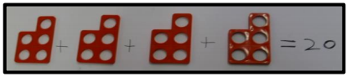

Key facts and expectations

Reception:
Multiplication is introduced as doubling in EYFS and is the first exposure that children have of groups of the same amount or repeated addition.

Year 1 and 2:
As children move into Key Stage 1, pupils begin to count in groups of 2, 5 and 10, look at repeated addition and introduce the concept of multiplication. In Year 2, multiplication tables are more formally learnt and children practise these regularly to build up confidence and accuracy with recall.

Year 3 and 4:
Learning multiplication facts is a key focus area for Years 3 and 4 and builds on prior learning from Year 1 and 2. By the end of Year 4, all children will have learned up to 12 x 12 (and corresponding division facts) and have instant recall of these facts. The chart below shows the order that multiplication facts are learned in, with 2x,5x and 10x all being learned first, then 3x, 4x, 8x and finally 6x, 7x, 9x, 11x and 12x. There is also a focus on pupils' understanding that the inverse of multiplication is division and the intrinsic relationship between the two operations.
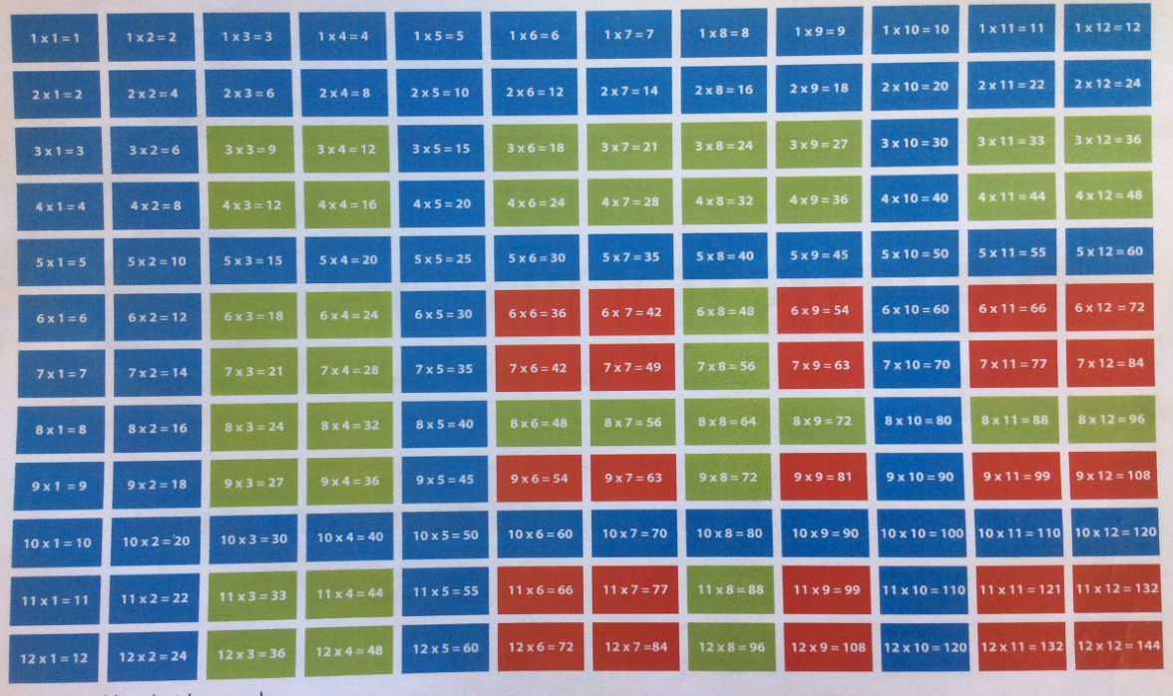

Year 5 and 6:
Once secure in their understanding of the multiplication and division facts, in Year 5 and 6, pupils apply these to calculating with fractions, decimals and percentages, with particular focus on conversions between the formats. Knowledge of multiplication and division facts also plays a vital role in converting between units of measurement and in algebra and scaling.

Written methods

Representations in Reception
Pupils are given an opportunity to manipulate and experience a range of resources in real life contexts and through role play. They are encouraged to solve real life problems e.g. If one pair of welly boots = 2 then 3 pairs = 6

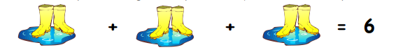
They are encouraged to draw pictures and represent their mathematical thinking through various representations e.g. bead strings, numicon, cubes.

Strategies used in Year 1

Number lines:
Use concrete representations such as bead strings, numicon or cubes etc. to make sets or groups of various sizes. Use number lines alongside other mathematical equipment to represent repeated addition counting in regular steps of various sizes.

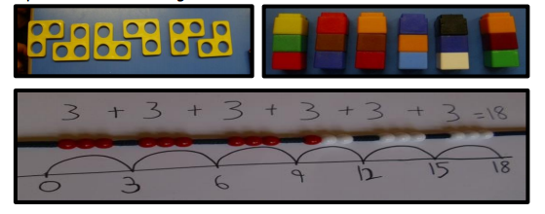

The images above, link the concrete with the pictorial and with the abstract.

Strategies used in Year 2

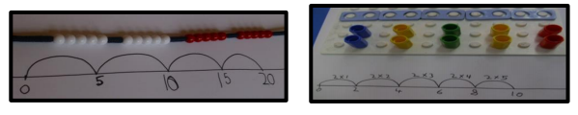
Year 2 should consolidate the use of methods in Year 1 as well as introduce the use of arrays to represent multiplication statements. These should focus on 2, 5 and 10x tables but of course can then be applied to other multiplication facts as well.

These arrays should be created using concrete apparatus initially before moving on to a pictorial representation. Arrays should also be shown in different orientations to show that multiplication is commutative.

5 x 3 = 15 3 x 5 = 15
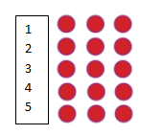
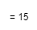
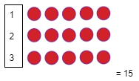

Strategies used in Year 3

Arrays will be consolidated as the main written method in Year 3. This will begin initially with 1 digit multiplied by 1 digit, leading on to 2 digit by 1 digit. For this, children should apply their understanding of partitioning to support them in developing the grid method. The children should partition the numbers in the ways they find easiest to calculate.

Partitioning:

Concrete and pictorial Abstract
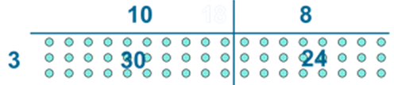

Children should be encouraged to partition the numbers in a way that makes the calculation easy for them and to become more efficient as they become more fluent in using known facts.

Strategies used in Year 4

As the children progress into Year 4, they will be shown how to use the grid method to support them in a more formal method of multiplication. This includes progressing on to multiplying together 2 digit and 2 digit numbers. Children will be taught to link the grid method with the expanded multiplication method.

32 x 24 =
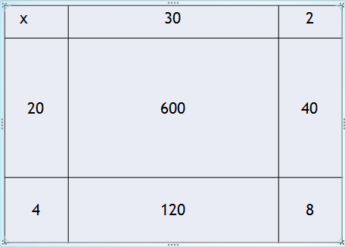
3 2
x 2 4
8 ( 2x4)
1 2 0 ( 30 x 4)
Links to… 4 0 ( 2 x 20)
6 0 0 (30 x 20)
7 6 8

Strategies used by Year 5:
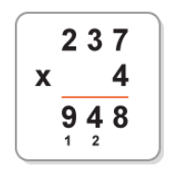
Children in Year 5 will learn to compact their method (if necessary linking with grid method) for long multiplication, leading into short multiplication

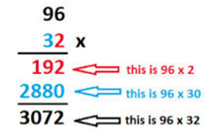
Strategies used by Year 6:

Children in Year 6 will consolidate their understanding of the formal written methods of multiplication taught in Year 5, and apply these across a range of scenarios and with decimals.

Division
Definition
Dividing is a quick way of subtracting several lots of the same number or quantity, or splitting it up into equal groups. Multiplying and dividing are the inverse or opposite of each other.

Mental calculations
- Counting forwards and backwards in equal steps e.g. 2’s, 5’s, 10’s.
- Rapid recall of multiplication facts.
- Partitioning.
- Secure understanding of place value.
- Multiplying and dividing by 10, 100 and 1000.
- Doubling and halving.
- Using multiplication as the inverse of division.

Key facts and expectations

Reception:
Division is introduced as halving in EYFS and is the first exposure that children have of sharing or grouping items. .

Year 1 and 2:
As children move into Key Stage 1, children are taught that division is the process of sharing or grouping. They are taught that division is the inverse of multiplication and that they can use known multiplication facts from their 2, 5 and 10 times table knowledge to help them to calculate division answers. .

Year 3 and 4:
Children in Year 3 and 4 have a key focus on multiplication facts (see multiplication section for more details) and the concept of division being the inverse operation of multiplication is consolidated. As children progress with learning their multiplication tables, they also learn and recall division facts.
Year 5 and 6:
Once secure in their understanding of the multiplication and division facts, in Year 5 and 6, pupils apply these to calculating with fractions, decimals and percentages, with particular focus on conversions between the formats. Knowledge of multiplication and division facts also plays a vital role in converting between units of measurement and in algebra and scaling.

Written methods

Representations in Reception
Pupils should have many practical experiences of sharing objects e.g. sharing between 2 people, or finding ½ of a group of objects. Pictures should be introduced as a next step to represent this. Drawings and diagrams should be increasingly used to represent and demonstrate sharing.
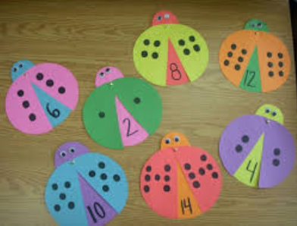
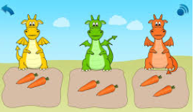

Strategies used in Year 1 and 2

Sharing

Concrete Pictorial
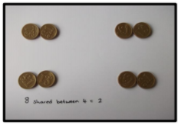
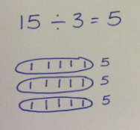

Children should begin sharing using manipulatives, moving on to a pictorial representation. The circles to share into should be lined up as above with lines also one per box so that links can be made with arrays and multiplication.

Grouping
Using a number line:
Completed number lines should be introduced to help record grouping strategies. This would involve the principle of repeated subtraction (and repeated addition as an alternative strategy). In Year 2, partial number lines may be used and blank for those children who have a secure understanding.

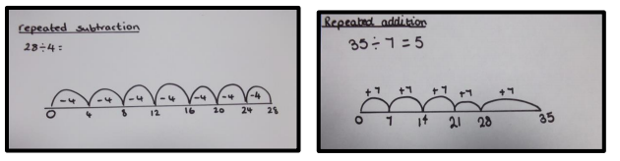
Again, these pictorial images should be supported initially with concrete examples (as above) using a range of equipment including bead strings.

Use of arrays to show division:
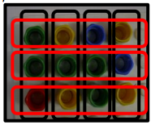
Arrays are useful in linking multiplication and division facts. If you have 12 counters, you can generate and demonstrate division easily to support the use of the number line and showing the inverse of multiplication.
This links with sharing as shown above.

Strategies used in Year 3

As with Year 1 and 2, arrays are used to show division facts and partition larger numbers. This can then link in with the number line.

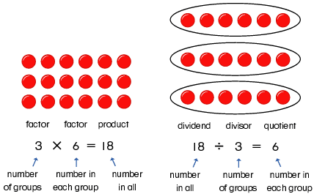

Children will then progress onto using coin numbers (known multiplication facts using 1x, 2x, 5x, 10x, 20x, 50x 100x the divisor) to help them to work with larger calculations such as 3 digit divided by a 1 digit and numbers including remainders.

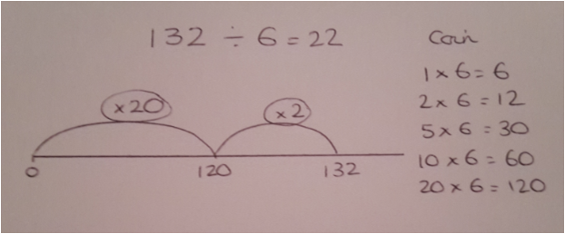
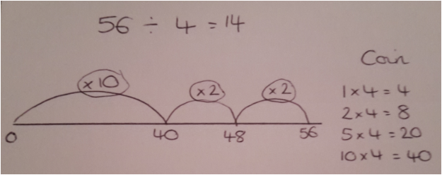

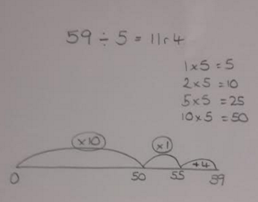

Strategies used in Year 4
In Year 4, children are taught to find groups through using short division. Children should still use coin numbers to support them with this method if needed and solid understanding of multiplication tables will support pupils in calculating how many ‘groups’ of the divisor they are finding. Remainders will be shown where you cannot fit any more groups of the divisor into your remaining number.

Concrete and pictorial Abstract

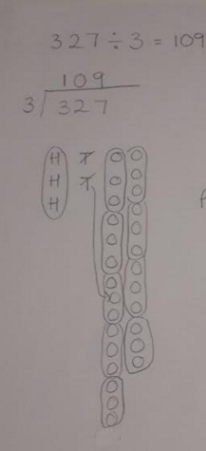

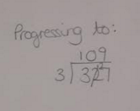

Strategies used in Year 5

As children move into Year 5, they will continue to consolidate the method of short division and apply this to increasingly larger calculations, dividing numbers with up to 4 digits by 1 digit.

Strategies used in Year 6

In Year 6, children will learn how to divide 4 digit numbers by up to 2 digits. They will continue to use the method of short division but will use a compound multiples method to help them to identify how many groups of the divisor fit within the dividend. For example, if children were completing the calculation 7523 ÷ 46, then the following compound multiples will be listed by the children to help them to calculate their answer whilst using the method of short division.

Multiples of 46:
40 + 6 = 46
80 + 12 = 92
120 + 18 = 138
160 + 24 = 184
200 + 30 = 230
240 + 36 = 276
280 + 42 = 322
320 + 48 = 368
360 + 54 = 414

Additionally, in Year 6 remainders are required to be shown as both decimals and fractions. To calculate fractions, this will be the remainder over the original divisor (and simplified if possible). For decimals, children may be able to convert a fraction to a decimal, or can continue the short division after the decimal point as below.

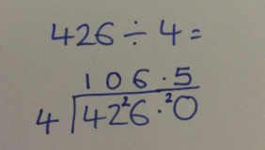

Children in Yr 5 and 6 are also taught that division questions are presented in many formats, including the ones below.
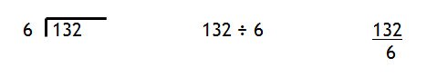

Algebra

What is Algebra? Why is it important?

Algebra is a way of thinking and a set of concepts and skills that enable pupils to generalise, model, and analyse mathematical situations. Algebra provides a systematic way to investigate relationships, helping to describe, organise, and understand the world. Although learning to use algebra makes students powerful problem solvers, these important concepts and skills take time to develop. Its development begins early and should be a focus of mathematics instruction from EYFS through all key stages.

The use of the equals sign =

In Maths equality (=) means balance between two sets and inequality (≠) means an imbalance.

Algebra requires pupils to solve simple equations that involve addition, subtraction, multiplication and division with a deeper understanding of the equals symbol. Using concrete resources to start with, they should be able to explore the equality and inequality of values of numbers.

A helpful pedagogy to use is, ‘What’s same and what’s different on both sides of the equation?’ There must be an opportunity to experience some examples of inequality to appreciate equality in a greater sense.
7 ≠ 8 - 3 ( not equal ≠ )

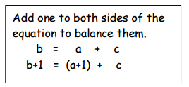
In early number work, children should be encouraged to look for patterns and generalise by drawing out similarities.

10 = 1 + 9
11 = 2 + 9
12 = 3 + 9

Later, they should be encouraged to complete the sequence to the nth term. e.g. 5, 8, 11, 14, 17,…… so the nth term = 3n + 2.
Pupils should be given the opportunity to find the unknown or the missing number in all areas of calculations.
E.g. If each banana costs 2p more than an apple, what is the cost of 3 bananas?
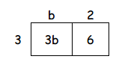
Price of one apple = b
A banana would cost b + 2
3 bananas would cost 3(b + 2) = 3b + 6
What is the cost of 5 apples?
5 apples would cost 5 x b or 5b

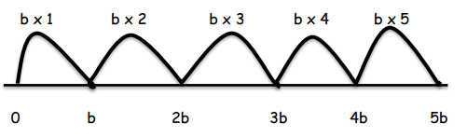

Pupils should be encouraged to make connections
e.g. 3 x 2 + 3 x 4 = 3 x 6

Find the missing numbers to solve problems
e.g. 10 ÷ 5 = 20 ÷ a
10/5 = 20/a

Multiply both sides of the equation by 5: 5 x 10/5 = 20/a x 5

Then multiply both sides of the equation by a: 10a = 100/a x a

Finally, divide both sides of the equation by 10: a = 10

Pedagogical Approach

- Developing pupils’ understanding of number and place value is essential and should be explored daily.
- The strategies chosen should aim to develop pupils’ conceptual understanding of calculation.
- Models, images and resources (representations) should be used throughout all key stages.
- Pupils should be encouraged to develop independence, and to select and use resources to support their learning.
- Practical activities should be a regular feature of maths lessons.
- Activities should be differentiated to suit the needs of the pupils.
- Opportunities to work within mixed ability groups should be explored.
- It is more effective to provide pupils with one question to practice the same skill rather than lots of different questions.
- Solving problems should be integral to the maths curriculum.
- Pupils should be encouraged to take risks, make mistakes, and learn from their experiences.
- Teachers will explore misconceptions with pupils in order to deepen their understanding.

Fluency, reasoning and problem solving

What does fluency, reasoning and problem solving look like in solving calculation questions?

These are the three aims from the 2014 Mathematics National Curriculum which are to ensure all pupils:
- become fluent in the fundamentals of mathematics, through varied and frequent practice with increasingly complex problems over time, so that pupils develop conceptual understanding and the ability to recall and apply knowledge rapidly and accurately
- reason mathematically by following a line of enquiry, conjecturing relationships and generalisations, and developing an argument, justification or proof using mathematical language
- can solve problems by applying their mathematics to a variety of routine and non-routine problems with increasing sophistication, including breaking down problems into a series of simpler steps and persevering in seeking solutions.

The 2014 mathematics curriculum states that
‘Mathematics is an interconnected subject in which pupils need to be able to move fluently between representations of mathematical ideas… (all) pupils should make rich connections across mathematical ideas to develop fluency, mathematical reasoning and competence in solving increasingly sophisticated problems.’

Examples of fluency, reasoning and problem solving:

8 x 5 = 40

Starting with this problem, pupils who demonstrate good fluency, reasoning and problem solving skills are able to use this fact to create others such as:
