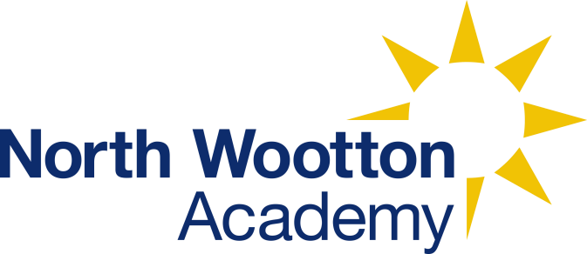 | North Wootton Academy  Priory Lane  North Wootton  Kings Lynn  Norfolk  PE30 3PT
Name of policy: | Art
Lead member of staff with responsibility for this policy: | Michele Buschman
Date of implementation: | 17th April 2023
Details of dissemination: | The policy is available for all staff, visitors, pupils and parents on the school website.
Linked Policies: | Curriculum Policy
Frequency for review: | Annually – Under review

When we are artists, we are going to respond to, find inspiration and create artwork remembering to express what we see, feel and think about it and how it relates to life – past and present.
Intent
At North Wootton, our intent is for children to be knowledgeable in historic and modern art, and able to express themselves through different artistic means and styles.
As a school, we believe that art is a vital and integral part of children’s education. It provides them with opportunities where there is no language barrier to develop a range of ways in which they can share and express their individual creativity and improve their mental health, whilst learning about and making links with a wide spectrum of different types of art in our society.
Art contributes to children’s personal development in creativity, independence, risk taking, judgement and self-reflection. Moreover, it enables pupils to develop a natural sense of wonder and curiosity about the world around them and therefore links strongly to our school values.
Our focus is to develop proficiency in the skills of drawing, painting, understanding colour, shade and sculpture, with the overall aim of developing a rigorous understanding, critical awareness and sense of inspiration of art and design.
The art curriculum will develop children’s critical abilities and understanding of their own and others’ cultural heritages through studying a diverse range of key artists and designers throughout history.
Children will develop their understanding of the visual language of art with effective teaching and carefully thought-out sequences of lessons and experiences. Understanding of the visual elements of art and design (line, tone, texture, colour, pattern, shape, 3D form) will be developed by providing an accessible and engaging curriculum which will enable children to reach their full potential.
Implementation
We teach a knowledge and skills-based art curriculum, which allows children to express their creative imagination as well as providing them with opportunities to practice and develop mastery in the key elements of art: drawing, painting, printing, textiles and sculpture. This is supported through the studying of key artists and the development of a knowledge of their work.
Lessons are taught in blocks of lessons during each half term. The lessons sequence of lessons involves:
- studying existing pieces of art and their artists - what do we see, know, guess?
- identifying the skills, techniques, purpose and effects use
- Practicing these in sketches to implement them skills in an art piece
- Given constructive feedback and next steps, combined with some time to self-critique and reflect
- Creating a final piece.
The evidence of their work is collected within the art sketch book which follows the children through the school. Photographs of larger, group or 3D pieces are also kept within this book.
Where possible art work and projects are related to other areas of the curriculum through cross-curricular planning. This encourages the children to make connections between areas of learning and increases their understanding of how art and design is integral to the world around them and people’s lives.
In some circumstances the process which the children go through may be of more value to their learning than the outcome of an activity. We do this best through a mixture of whole-class teaching and individual/group activities. Teachers draw attention to good examples of individual performance as models for the other children. They encourage children to evaluate their own ideas and methods, and the work of others, and say what they think and feel about them. This links to our Speaking and Listening policy in school.
Within the EYFS, Art is carried out through adult-led activities and enabling environments. This is under Expressive Arts and Design.
Impact
The pupil’s knowledge of art history and visual elements of art is recorded through half-termly quizzes whilst the development of their physical skills will be evaluated against Key Skill Rubrics in drawing, painting, sculpture and other art, craft and design techniques.
The judgements and assessments made against these will be validated by the Art coordinator on an annual basis with feedback given to staff.

